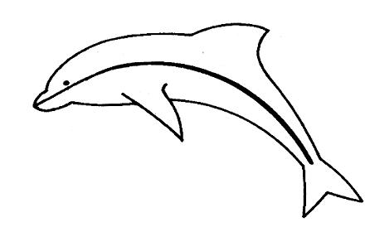

Poole Yacht Racing Association

Ron Gentle (Hon Secretary)
8 Dudsbury Avenue,
Ferndown,
Dorset.
BH22 8DU Tel: 01202 871038
e-mail secretary@pyra.org.uk

APPLICATION FOR

CREW / CO-OWNER MEMBERSHIP 2026

Name |  | Phone (h)
Address 1 |  | Phone (m)
Address 2 |  | Phone - Shore Contact
Address 3 |  | e-mail
Post Code |  | Yacht Club

The information you provide in this form will be used solely for dealing with you as a member of The Poole Yacht Racing Association.

Please indicate x

CREW MEMBER |  | Crew |  | £10.00 |  | £ - 00
 | Boat |  |  | Sail No |  | £ - 00
CO_OWNER MEMBER |  | Co-Owner |  | £10.00 |  | £ - 00
 | Boat |  |  | Sail No |  | £ - 00

 | Extra copy of Red Book | £4.00 (each) |  | £ - 00
 | PYRA Battle Flag | £16.00 |  | £ - 00
 | Donation to prize fund |  |  | £ -
 |  |  | Total | £ -_____
Payment:

Cheque – Made payable to PYRA

By BACS – to sort code 30-96-73 A/c 01160457 – Add “Crew” or “Co-Owner as reference

I Declare:
I will be governed by the rules, conditions of entry and safety statements as set out in the Red Book 2026, together with any amendments.

Signature:-...................................................................Date:-.............................

PYRA - APPLICATION FOR CREW MEMBERSHIP 2026

CREW MEMBERSHIP is open to any person. An applicant for Crew Membership must submit:-
i) Form of Application for Crew Membership (or renewal).
- The relevant annual subscription.
Crew membership is acquired when such application is accepted by the Hon. Secretary.

CO- OWNERS. Each boat only carries one vote at the AGM. Owners other than the Full Member are advised that they may register as co-owners if they so wish.

