PYRA CANDLELIGHT DINNER
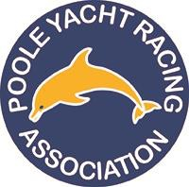
SATURDAY 13th DECEMBER 2025

ROYAL MOTOR YACHT CLUB
Tickets £50.00 per person

7.00pm (Carriages after 11.30pm)
Prize Giving & Festive 3 Course Dinner
BRING CASH for Charity Raffle (Dorset Air Ambulance)
Dress Code: Black Tie / Smart Evening Wear
Bring your dancing shoes ready to dance the night away to Rich Baxter

Contact for Booking: | Boat Name:
Telephone Number: | E-Mail:

  - Please list the guests attending on your table including yourself and add codes as shown on the menu attached
please add any additional dietary requirements in the notes below and these will be passed on to the catering team
  - We will endeavor to seat group bookings together but please use the notes column for any special requests.

 | Guest Name | Start  Code | Main  Code | Dessert  Code | Notes/Dietary Requirements
1
2
3
4
5
6
7
8
9
10
Completed booking forms and full payment must be received before 28th November
Please download this form, complete and return By E-mail to: social@pyra.org.uk
PAYMENTS – By BACS to: PYRA, 30:96:73, 01160457
Please include “CDL” and BOAT NAME so that characters used are minimized
For any further queries please contact by email social@pyra.org.uk

